The Ombuds Office 2021-2022

Annual Report

Iowa State University

July 1, 2021 – June 30, 2022

PREPARED BY

Laura C. Smythe

University Ombuds

November 30, 2022

MESSAGE FROM THE OMBUDS
This 2021-2022 Ombuds Office Annual Report represents the first report in my tenure as the University Ombuds for Iowa State University. This report represents 10 months of work provided by MWI (specifically Ombuds Chuck Doran and Jai Calloway) who served ISU as external Ombuds and two (2) months of work provided by Laura Smythe, internal Ombuds. My first day was April 18, 2022. It is my distinct pleasure and my honor to serve the graduate and professional students, merit staff, professional and scientific staff, faculty, and administrators as a resource for constructive and respectful communication and collaboration. I appreciate this University’s commitment to providing an excellent education within a safe and welcoming environment to all of our students and a safe, inclusive and invigorating workplace for all of our employees.
I appreciate President Wendy Wintersteen, Senior Vice President and Provost Jonathon Wickert and Associate Provost for Faculty Dawn Bratsch-Prince, the Faculty Senate, the Professional and Scientific Council and the Graduate and Professional Student Senate for their support of the Ombuds Office and for recognizing that this office is integral to accomplishing the University’s Strategic Plan particularly as it pertains to the goal “to be the university that cultivates a diverse, equitable and inclusive environment where students, faculty and staff flourish.” I hear every day from visitors how much they appreciate the opportunity to visit with somebody outside of their chain of command, somebody who can help them informally solve problems and somebody who listens without judgment, and with solely an intent to hear and support. The scaffolding of communication and conflict management skill sets I am able to offer and the support I am able to give is due in large part to the unique nature of the ethical tenets by which this office operates: confidentiality, impartiality, informality and independence. Campus-wide support of this office reflects the deep commitment to valuing each and every person who makes up Iowa State University community. It is an honor for me to be of service to you.
This past year has brought both hope that the pandemic will end, and clarity that we have entered into a new “normal” in which online modalities of communication, learning and work have been experienced as both a gain in flexibility and as a challenge for creating equity of learning experiences, work experiences and for understanding how best to leverage and manage changing expectations about how we interact with one another. Neurobiologists tell us that during the pandemic we lost some skill sets in both our communication acumen and our social intelligence. As we navigate our way through new norms, I encourage all of us to keep practicing grace, compassion and patience with one another.

Laura C. Smythe, M.A., M.A, J.D.
Iowa State University Ombuds, November 30, 2022
The Ombuds Office 2021 – 2022 Annual Report
Iowa State University
The Ombuds Office adheres to and operates by the Standards of Practice and the Code of Ethics established by the International Ombudsman Association (IOA) for Organizational Ombuds. The four key tenets are:
- Confidentiality*
- Impartiality/Neutrality
- Informality
- Independence
(Definitions Appendix A)

*Certain limitations apply, e.g., concern for imminent harm to self or others and abuse of populations who cannot take care of themselves.

History of the Iowa State University Ombuds Office
The Ombuds Office at Iowa State University has now been in place for 14 years. Laura C. Smythe joined the University in April 2022 as the second, full-time and in-house University Ombuds.

Mission, Purpose and Function
The mission of the Iowa State University Ombuds Office is to foster and support an inclusive, positive and productive learning, working and living environment for faculty, staff, graduate/professional students, and administrators. The office fulfills this mission by promoting mutual respect, scaffolding mindful communication, assisting with the development of inclusive cultures, enabling fair processes and helping to manage and resolve problems that emerge within the university.
The primary purpose of the Ombuds Office is to assist members of the university community with resolving their own problems or conflicts informally, and at the lowest level possible, by providing a safe place where individuals can speak confidentially and candidly about their issues of concern. The Ombuds services are voluntary, and people contacting the Ombuds are referred to as “visitors”. Visitors receive assistance with clarifying their concerns, understanding applicable policies and procedures, and identifying resources and response options to address their concerns. Like many U.S. academic Ombuds offices, the Iowa State University Ombuds Office embraces a solutions-focused approach to problem solving. Although the Ombuds may help the visitor to identify possible response options, the visitor always remains empowered to, and responsible for, selecting her or his or their own course of action or non-action. The office also serves as a catalyst for positive change by helping to identify issues of concern, and by providing timely upward feedback when appropriate.

The Ombuds Office mission and purpose are accomplished by the following:

- Listening to concerns compassionately and non-judgmentally
- Analyzing problems and exploring possible response options
- Providing information about policies and services
- Providing leadership, management and supervisory consultation/coaching
- Referring to campus and community resources
- Coordinating with other university offices
- Working with groups of all sizes to develop cultures and climates of respect and collaboration

- Providing individual and group/unit conflict coaching
- Facilitating dialogue between individuals and groups
- Mediating disputes
- Providing training in human relations, communication and conflict management
- Noting trends and impacts
- Identifying means to improve problematic systemic trends

The benefit to Iowa State University is the potential for greater workplace satisfaction, improved morale, greater retention of students and employees, higher efficiencies and fewer unnecessary formal processes, including legal action.
The Ombuds Office does not maintain identifiable records about individual or group issues. The office keeps only non-identifying statistical information and keeps it only long enough to generate each year’s annual report.
An Ombuds is not an official agent of the university and will not serve as a witness nor offer testimony in any formal proceeding, unless required by law. Individuals using the services of the Ombuds Office retain their rights to all formal procedures ordinarily available to them and are solely responsible for determining their course of action.

“Every interaction has an emotional subtext. Along with whatever else we are doing, we can make each other feel a lot better, or a little worse – or a lot worse,” (Goleman, 2007, p.14).

Year in Review
Iowa State University was served by two different Ombuds during the year 2021-2022. From July 1, 2021 – April 15, 2022, MWI Outsourced Organizational Ombuds Services provided external Ombuds services. Beginning on April 18, 2022 – June 30, 2022, Laura Smythe served as in-house Ombuds although serving remotely due to the housing situation in Ames. This report is submitted by Smythe and is a bit limited in scope due to the short duration of her tenure as of the end of this fiscal year. It does, however, capture the work done during the twelve-month period. MWI served 348 visitors while attending to 280 matters. Smythe served 60 visitors while attending to 35 matters. Matters are distinct concerns brought to the attention of the Ombuds Office. It is not uncommon for a visitor to have more than one matter.

Nature of Problems
Every organization has concerns or problems that emerge within the normal course of conducting business. Iowa State University, similar to other organizations, provides multiple resources in addition to the Ombuds Office to help members of the community address their issues constructively. It is the confidential, impartial, informal and independent features of the Ombuds Office that most often prompt visitors to seek Ombuds services, especially as an initial resource. While contact with the Ombuds Office is confidential, the presenting issues are tracked. In noting the nature of concerns the Ombuds Office can inform the University of areas requiring attention. Please see Figure 1 below for a distribution of subjects brought to our attention this year.

“It’s important to remember that forgiveness doesn’t mean condoning bad behavior, or that we need to interact with people who have hurt us. Discriminating wisdom…understands that all people are imperfect, that we all make mistakes. Being human involves doing wrong at times. This means that to judge one person is to judge the whole world. But to forgive one person is to forgive all the world – ourselves included.” – (Neff, 2015, p.199)

Figure 1: Subjects brought to the Ombuds Office.
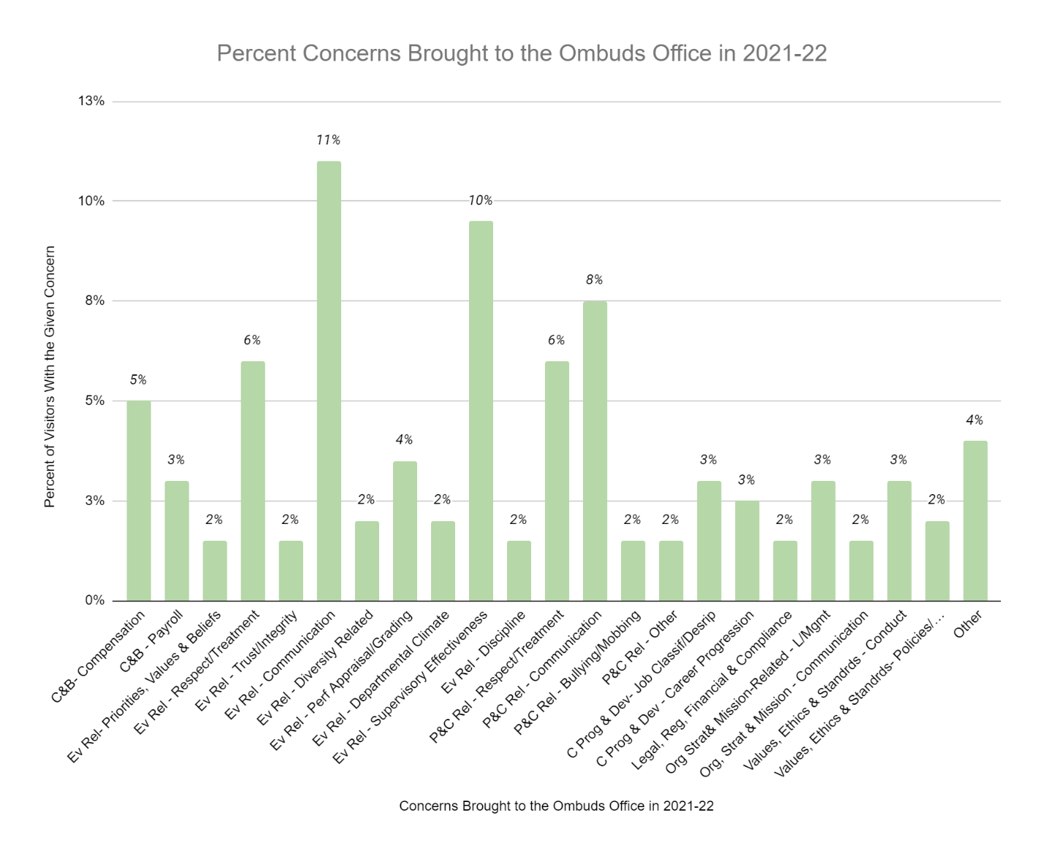
Note: Concerns brought to the attention of the Ombuds Office are delineated by IOA (International Ombuds Association) categories. This Figure represents all 12 months and reflects only those categories that respectively represent more than 2% of all matters brought to the attention of the Ombuds in 2021-2022. “Other” includes matters that did not fit well within IOA categories. Most commonly those included WorkFlex-related and Covid-related concerns. Please see Appendix C for a complete listing of IOA categories.

Nature of Visitors and Contacts

Table 1: Nature of Visitors and Contacts, 2021-2022
Female Non-Binary | Male | Self-Referred | Referred UHR Supervisor Other
26% 1.5% | 18% | 39% | 2.5% 9% 2.75%

Note: These numbers in Table 1 do not equal one hundred percent. Because visual assessment is not a valid means of assessing gender identification, the numbers above for both gender identification and referral source rely on survey responses and many surveys are never returned and other surveys are filled out incompletely.

University Affiliation
The Ombuds Office provides services to all faculty, all staff, graduate and professional students, and administrators of the university with the affiliation designation tied to the visitor/visitors initiating an individual matter. The affiliation of all individuals within a matter is not documented.
Figure 3 shows the distribution of cases based on the initiators’ university affiliation. The “Other” category includes graduate and professional students who recently graduated.

Figure 3: University Affiliation for 2021-2022

University Affiliation | Percentage
Merit Staff | 9%
P & S Staff | 31%
Faculty | 34%
Administrator | 8%
Graduate/Professional Students | 15%
Post-Doctoral Students | 2%
Other | 1%
Retiree | 0%

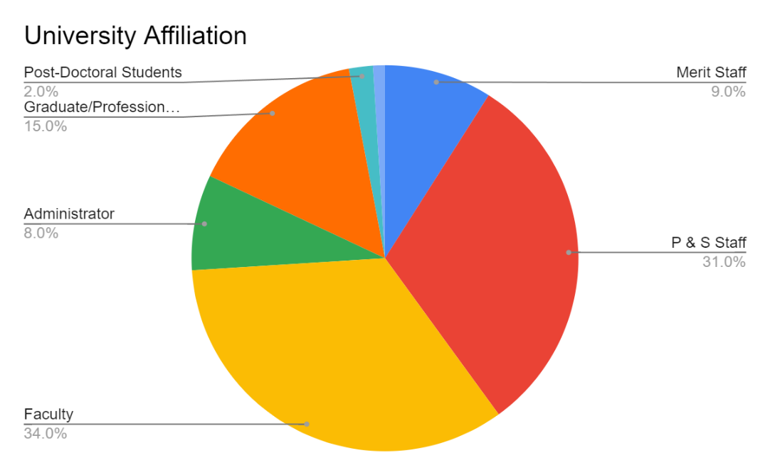

Individuals Served and Types of Appointments
Figure 4 below shows that single individual matters were the most common this year. Please note, that this data reflects only those who were visitors to the Ombuds office. It may be that a visitor had a concern about one or more other individuals. If those individuals were not contacted by the Ombuds then they are not counted as an individual served by the Ombuds. Please also note that some matters, regardless of the number of visitors involved, may require only a single contact with the Ombuds whereas other matters may require several dozen contacts over a period of weeks and/or months.

Figure 4: Number of Individuals Involved Per Case, 2021-2022

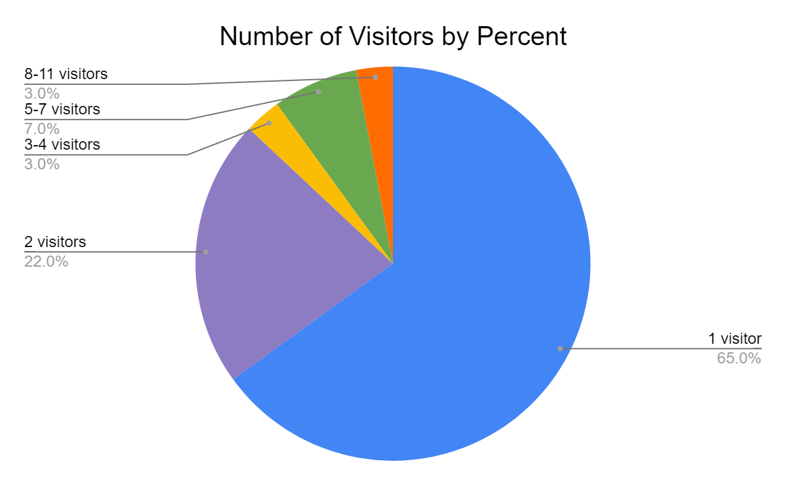

Due to the external nature of MWI’s Ombuds work and Smythe’s remote location, all Ombuds services in 2021-2022 were provided remotely. These services were offered via email exchanges, phone calls, and online meetings with a few text messages utilized by visitors to check on meeting availability. Most matters included a variety of contacts.

Outreach and Other Services
The Ombuds Office actively contributes to the University’s Statement of Aspiration: “to be the university that cultivates a diverse, equitable, and inclusive environment where students, faculty, and staff flourish” by addressing concerns for students, faculty and staff that would otherwise pose barriers to the relationships the students and faculty have with one another and with their peers. This support helps to create an environment that feels, and is, safer and is also therefore more conducive to learning and working. The Ombuds also works with individuals and entire units and departments to develop and promote respectful communication and conduct which enhances collaboration and the sense of feeling valued both of which result in improved efficiency and increased retention of students and employees.
Outreach activities include coaching leaders at all levels, facilitating difficult conversations and training/teaching about: respectful communication, mediation skills, conflict management, and change management, and through individual seminars and group facilitations for academic departments and support units.
Outreach
In her first two and a half months, Smythe reached out to leadership at all levels to introduce herself and to get to know the many colleges and units across campus. During her first two months, Smythe met with more than 35 leaders, and worked with three different units on climate and culture concerns. She looks forward to providing more details about additional outreach and services in next year’s report.

Other Services
Professional Service
The Ombuds is a member of the International Ombudsman Association (IOA) and the Ombuds Committee in the Dispute Resolution Section of the American Bar Association (ABA). Smythe was honored to present at the International Ombuds Association Annual Conference in April on “Trauma-Informed Ombudsing”. The application of trauma-informed practices to the profession of an Organizational Ombuds was the first of which this Ombuds is aware.
Smythe also served on a Sub-Committee of the ABA – DR to develop programming for Ombuds Day 2022.

Professional Development
The Ombuds is committed to ongoing professional development and engages regularly in reflective practice with other experienced academic, healthcare, government and corporate Ombuds through video conferencing, email and phone consultation, when opportunities become available. Reading and research on relevant topics are also part of the Ombuds’ regular practice. Smythe was also asked to confer with several peer Ombuds offices regarding ethical practice for an Organizational Ombuds in Higher Education.

Efficacy of the Ombuds Office
The definition of a successful outcome and Ombuds efficacy cannot be gauged by whether a problem is ultimately resolved according to a visitor’s satisfaction or an Ombuds’ preference. Some visitors consult with the Ombuds with the hope that the Ombuds will solve their problem for them. It is always the visitor’s decision regarding how, or whether, they choose to resolve their issues. They retain full agency regarding their response. There are multiple descriptors of success:
- Visitor better understands her concern and identifies solution options.
- Visitor feels better supported and less stressed.
- Visitor is better informed and prepared to self-advocate, act or not act and better understands the potential benefits and consequences of his choices.
- A potential problem is avoided.
- Further deterioration or escalation of a situation is avoided.
- A manifest problem is resolved.
- A policy or system problem (and a potential modification) is identified.
- Observations and recommendations are made to one or both of the governing bodies.
- Entire units are scaffolded to recognize and address barriers to successful and respectful communication and collaboration.
Helping visitors and all parties to be more respectful, effective, constructive and fair in seeking solutions to their concerns, and to reduce harmful tensions or hostility are considered successful outcomes from the perspective of the Ombuds Office.
There are, however, many problems where no remedies or resolution options are available. Some cases can leave visitors with few options, such as:
- Termination for cause or performance;
- Intractable disagreement over disciplinary actions and/or evaluation ratings;
- Differing expectations for a position and/or for the corresponding compensation;
- Many academic or employment decisions with clear processes and policies; and
- Many academic or employment decisions where no clear procedures or policies exist.
In these cases, being heard and being able to confirm that a relevant policy or action was appropriately or fairly applied, including talking about possible next steps, are crucial to moving forward for all parties. Where procedures or policies are vague, this also helps visitors gain insight that can assist their decision-making about next steps.
The Ombuds assumes the validity of the experience and perspective of each visitor. This is critical to the quality of being heard and understood that most visitors tell me is invaluable. Because I do not judge their experience or their perspective, visitors are empowered to be honest and to be vulnerable and because I listen without judgment, visitors often feel safe enough to explore their own conduct, respond to others’ conduct and to take responsibility for that which they can control. This intervention alone has likely lessened the emergence of unnecessary escalation. The most common and highly appreciated benefit reported to the

Ombuds is being heard without judgment or fear of retaliation and being assisted with sorting out issues and response options. Visitors report appreciating the safety they feel that results from the confidentiality, impartiality, informality and independence of the office. Visitors report feeling supported, respected, calmed and empowered with specific skill sets to address their situation.

Assessment of Utility
When assessing the impact of Ombuds services, results are difficult to measure since visitor perceptions of outcomes are often tied to factors outside of an Ombuds’ role (an Ombuds cannot reverse decisions, change a grade, or adjudicate complaints, etc.) In addition, confidentiality precludes the use of many of the usual forms of evaluation.
The Ombuds Office uses two methods to assess the outcomes and impacts of services. The first is a survey form automatically sent to Visitors when the Ombuds closes a matter. It is not always easy to tell when a matter is over and so there may be some lag between a final visit and a survey being sent. Moreover, return rates for surveys are only about 20%.
The second form of assessment is based on the Ombuds’ self-analysis of completed cases ranking each case resolution between ‘Satisfactory’, ‘Neutral’, and ‘Unsatisfactory’. These assessments are not a measure of visitor satisfaction. They are used as an element of reflective practice. The scale attempts to help the Ombuds evaluate the service provided and outcome of each case as objectively as possible and Smythe’s self-analysis is captured in Appendix D. Without being privy to MWI’s own internal note-keeping, this Ombuds cannot meaningfully reflect on this second form of assessment for them this year. Here, however, are some comments MWI received in surveys as a result of their work:

- “She was great!”
- “The guided conversation was very helpful and Chuck’s suggestions will be really helpful for building relationships and moving forward.”
- “Unless people want to come to the table there is nothing they can do.”
- “I have called the Ombuds twice and had a positive experience (and positive outcomes) both times; I would not hesitate to call again in the future. I also recommend the Ombuds as a resource to my colleagues.”
- “This office did not help me one bit.”
- “The service was extremely helpful.”
- “Ombuds was warm and friendly, very supportive and encouraging, helped me feel comfortable. Very helpful advice and framework offered.”
- “I really appreciated the experience.”
- “I was incredibly impressed with my ombuds experience.”
- I appreciated the professional work of Jai Callaway!”
- “Chuck Doran was extremely helpful, both in terms of active listening skills and assistance navigating various processes.”

Here are a few comments Smythe received as a result of her work:
- “I’m telling everybody I know to reach out to her for help.”
- “I can’t believe she made me laugh. I can’t remember the last time I laughed.”
- “I’m so grateful to Laura. I felt so alone before I contacted her and she was so supportive and helpful.”

Ombuds Observations and Comments
Most concerns or problems brought to the Ombuds Office are specific to a set of circumstances or particular individuals. However, when issues appear to be systemic within a college or division, or reflect broader trends that might warrant further attention, the Ombuds may share these proactively and directly with the relevant administrator(s) and make recommendations in accordance with the professional standards of Organizational Ombuds.
This Ombuds is not privy to observations MWI may have noted in their work with Iowa State University for the majority of 2021-2022. After only a few months, I am hesitant to note many trends. There are just two observations I wish to highlight.

Graduate and Professional Students
The constituency with whom I spent the most time in my first two months were graduate and professional students. Graduate and professional students are, from my perspective, a uniquely-vulnerable constituency at all universities; particularly R1 universities. They are often incredibly reliant upon only one or two major professors and/or principal investigators for their funding, their tutelage and their entry into their chosen profession. This means that when a conflict erupts between a graduate student or professional student and a scientist and/or major professor the students are often very reluctant to speak up for fear of losing their financial and professional support. This dynamic is exacerbated for our international graduate and professional students who are navigating the rigors of graduate school within a context of learning social norms, values and interweaving systems. Faculty and scientists who shepherd these students have tremendous power to shape lives and careers. Training for these mentors should be mandatory and regularly recurring. Training that includes some stories from our graduate and professional students might provide meaningful context within which to learn how they can be perceived.

Remnants of Covid and Remote Work
Although we are all eager for Covid to be behind us – it isn’t. Individuals, units, departments and families continue to navigate differing opinions about what is safe behavior and what isn’t. Many staff employees are also struggling with not only who gets to work from home, and how often, but also how to maintain efficient communication and reliable and respectful communication when the presence of employees ebbs and flows

throughout the week. Supervisors and leaders at all levels can encourage constructive and reliable communication through some of the following practices:

- Maintain regular and consistent meetings for the unit or department. It is easy to drop a meeting when feeling overwhelmed and with nothing urgent to discuss. Regular and reliable meetings, however, create opportunities for informal exchanges and unit cohesion and team building that do not occur without such opportunities. This is particularly important for units and departments who have multiple staff employees on varying WorkFlex schedules. These regular meetings may be their best and most reliable opportunity to interact with some colleagues and supervisors.
- Ensure that all team members are adhering to a calendar system that is visible for all who need to know where somebody is. It is very frustrating to need help and have no idea how to locate a supervisor or a colleague about a time-sensitive matter during the work day. It is also frustrating, and embarrassing to be asked where a colleague or supervisor is and to have to report that you don’t know where they are nor when they are expected to be back.
- Consider adding to your regular meetings a dedicated time (it need not be long) during which your unit reflects on values, resource allocation, and mindful analysis of patterns of communication and behavior which may no longer be serving you well. Building in time for collaborative reflection about how the department or unit is functioning enhances a sense of loyalty and teamwork.

The Ombuds Office exists to informally help individuals and bring observations and recommendations, as noted above, to the awareness of the governing bodies of the University. While the totality of issues brought to the Ombuds represents a limited number of people, they are nonetheless significant. It is generally understood that for every single visitor, there are likely many others who do not come forward and who have the same or similar issues. When responded to effectively by those who have both the responsibility and authority to manage this University, they are likely to steer the course of a culture to a more positive place. The Ombuds remains committed to helping all individuals collectively and collaboratively reach their individual and mutual goals in support of Iowa State University’s mission and values.

Appendix A
Ethical Tenets of the Organizational Ombuds
In fulfilling its purpose, the Ombuds Office at Iowa State University adheres to and operates by the Standards of Practice and the Code of Ethics for Organizational Ombuds as established by the International Ombudsman Association (IOA). Organizational Ombuds differ from Classical/Executive Ombuds and other types of Ombuds in that they do not conduct formal investigations where confidentiality cannot be maintained. Nor do they advocate for anything other than fair process. Organizational Ombuds are not official agents of the University and therefore are not required to report certain events as mandated by Federal law.

Confidentiality. All contacts, conversations and information exchanged with the Ombuds remain confidential and are not disclosed by the Ombuds without the consent of all parties involved. Exceptions to confidentiality exist when disclosure is necessary to protect someone from imminent harm and when otherwise required by law.

Neutrality and Impartiality. An Ombuds is an impartial person on behalf of all members of the university community. As such, the Ombuds remains impartial and unaligned. An Ombuds does not take sides, serve as an agent, represent or advocate on behalf of any party or the university. Rather, it is the role of the Ombuds to consider the facts, rights, interests, and safety of all parties involved in a search for a fair resolution to a problem. An Ombuds promotes and advocates fairness and justice.

Informality. Consultations are conducted ‘off the record’ and do not constitute notice to the university in any way. Organizational Ombuds are not mandated reporters for most Federal and State laws. An Ombuds does not become involved in, or part of, formal institutional processes (such as mandatory reporting, formal complaints, investigations, appeals, etc.), unless otherwise specified in policy, and then only as a neutral process observer. No personal information is retained or used for subsequent formal proceedings. An Ombuds will not serve as a witness nor offer testimony in any formal proceeding, unless required by law. Individuals using the services of the Ombuds Office retain their rights to all formal procedures ordinarily available to them and are solely responsible for determining their course of action.

Independence. To ensure objectivity, the office operates independently of all university entities and reports to the highest possible level of the organization. An Ombuds exercises sole discretion over whether or how to act regarding an individual’s concern, a trend or concerns of multiple individuals over time (IOA Standards of Practice).

Appendix B
Types of Services Offered by the Ombuds

A ‘matter’ is any new or recurrent issue (after a previous case closure) that is brought to the Ombuds’ attention by one or more individuals seeking assistance. While the Ombuds Office does market its services, it does not proactively seek or initiate matters.
Matters vary from a single informational visit to highly complex interventions involving multiple parties and meetings and requiring considerable time. There may be more than one matter initiated by a single visitor if each issue requires independent follow-up.
The number of matters represents a conservative figure since numerous contacts occur informally and spontaneously in the course of conducting Ombuds business, such as during university meetings, training workshops, periodic involvement within units (when multiple concerns emerge) and during training and outreach visits.

Mediations are formal facilitated discussions where an agreement is reached regarding future conduct. Some mediations result in written agreements. Other mediations are non-binding, good faith agreements between parties.
Facilitated Discussions are similar to mediations however, they are more informal, and rarely have written agreements.

Group Facilitations can be focused on team building, conflict management, culture development or a myriad of other subjects and are a combination of training and working through the leadership’s objectives for the group.

Witnessing is offered to visitors who wish to meet with others and who feel safer doing so with an impartial observer. The role of the Ombuds in this context is to ensure that all who participate feel heard and respected.

Coaching is offered to visitors who request it for themselves or, on occasion, when a supervisor of a new mid-level supervisor recommends the new supervisor work with the Ombuds to develop leadership skills, communication skills, conflict management skills, etc. Coaching is individually-tailored to the visitor’s requested skill-scaffolding.

Appendix C
International Ombuds Association Reporting Categories
Figure 1, Page 6

Category 1: Compensation and Benefits:
1.a. Compensation
1.b. Payroll
1.c. Benefits
1.d. Retirement, Pension
1.e. Other
Category 2: Evaluative Relationships:
2.a. Priorities, Values, Beliefs
2.b. Respect, Treatment
2.c. Trust, Integrity
2.d. Reputation
2.e. Communication
2.f. Bullying, Mobbing
2.g. Diversity-Related
2.h. Retaliation
2.i. Physical Violence
2.j. Assignments, Schedules
2.k. Feedback
2.l. Consultation
2.m. Performance Appraisal/Grading
2.n. Departmental Climate
2.o. Supervisory Effectiveness
2.p. Insubordination
2.q. Discipline
2.r. Equity of Treatment
2.s. Other
Category 3: Peer and Colleague Relationships:
3.a. Priorities, Values, Beliefs
3.b. Respect, Treatment
3.c. Trust, Integrity
3.d. Reputation
3.e. Communication
3.f. Bullying, Mobbing
3.g. Diversity-Related
3.h. Retaliation
3.i. Physical Violence
3.j. Other
Category 4: Career Progression and Development:
4.a. Job Application, Selection and Recruitment Processes
4.b. Job Classification and Description
4.c. Involuntary Transfer, Change of Assignment
4.d. Tenure-Position Security, Ambiguity
4.e. Career Progression
4.f. Rotation and Duration of Assignment
4.g. Resignation
4.h. Termination/Non-Renewal
4.i. Re-employment of Former or Retired Staff
4.j. Position Elimination
4.k. Career Development /Coaching/Mentoring
4.l. Other
Category 5: Legal, Regulatory, Financial and Compliance:
5.a. Criminal Activity
5.b. Business and Financial Practices
5.c. Harassment
5.d. Discrimination
5.e. Disability, Temporary or Permanent, Reasonable Accommodation
5.f. Accessibility
5.g. Intellectual Property Rights
5.h. Privacy and Security of Information
5.i. Property Damage
5.j. Other

Category 6: Safety, Health and Physical Environment:
6.a. Safety
6.b. Physical Working/Living Conditions
6.c. Ergonomics
6.d. Cleanliness
6.e. Security
6.f. Telework, Flexplace
6.g. Safety Equipment
6.h. Environmental Policies
6.i. Work Related Stress and Work-Life Balance
6.j. Other
Category 7: Services/Administrative Issues:
7.a. Quality of Services
7.b. Responsiveness, Timeliness
7.c. Administrative Decisions and Interpretation, Application of Rules
7.d. Behavior of Service Providers
7.e. Other

Category 8: Organizational, Strategic and Mission-Related:
8.a. Strategic and Mission-Related, Strategic and Technical Management
8.b. Leadership and Management
8.c. Use of Positional Power, Authority
8.d. Communication
8.e. Restructuring and Relocation
8.f. Organizational Climate
8.g. Change Management
8.h. Priority Setting and/or Funding
8.i. Data, Methodology, Interpretation of Results
8.j. Interdepartmental,
Interorganizational, Work, Territory
8.k. Other
Category 9: Values, Ethics and Standards:
9.a. Standards of Conduct
9.b. Values and Culture
9.c. Scientific Conduct, Integrity
9.d. Policies and Procedures NOT Covered in Above Categories
9.e. Other

Appendix E
Ombuds Smythe Self-Appraisal of Outcomes/Impacts of Matters 2021-2022
n = 35 (representing April 18, 2022 – June 30, 2022)

Outcome Category and Specifier
Resolved satisfactorily with Ombuds Office assistance n=29 83%
- Mediation: agreement/compromise reached through mediation; formal action avoided; visitor given another chance or situation otherwise satisfactorily resolved. | 20%
- Miscellaneous Techniques: conflict resolved short of mediation; may involve “shuttle diplomacy” or similar workshops intervention, with entire unit, or other techniques; formal action not taken. | 14%
- Facilitated Discussions: Ombuds served, by invitation or suggestion, as neutral observer; may involve role as moderator, but not mediator; visitor satisfied with outcome; formal action not taken. | 22%
- Coaching: Long-term coaching provided. | 34%
- Information only or “light coaching” was provided by Ombuds; and/or helps party to self-advocate. Visitor satisfied. | 10%
- Policy/Procedure or system modification/improvement. | 0%
- Other  Note that in this category more than one process may have been used for a single case and so the process noted is the primary one utilized. | 0%

Neutral Outcome (Ombuds had no direct impact) n=4 11%
- Neutral Listener: Ombuds role was primarily as a neutral listener; little or no ‘coaching’/or additional information was provided. Visitor already had or did not need information but needed ‘someone to listen’; may have received confirmation of ideas/plans, but nothing new added by Ombuds. | 75%
- Cancels or ‘vanishes’: Visitor initiated and then canceled or ‘vanished’ after setting appointment or before follow-up action was completed. | 0%
- ‘Unrepairable’: situation upon arrival (e.g. temporary help, already terminated, tenure was denied for appropriate reason, or visitor resigned). | 25%
- Other | 0%

Results Unsatisfactory n=2 6%
- Visitor disgruntled: with Ombuds efforts and discontinued visits or contacts. | 0%
- Visitor disregarded: advice/solution and suffered consequences. | 50%
- Lack of cooperation: unfair practice or situation not resolved nor corrected due to lack of cooperation. | 50%
- Other | 0%

On occasion, problems would re-surface or new issues arose with previously served visitors. Situations that deteriorate after concluding Ombuds involvement are not reflected in the Ombuds’ assessment above.

“Emotion is not opposed to reason; our emotions assign value to experiences and thus are the foundation of reason. Our self-experience is the product of the balance between our rational and our emotional brains.” (VanDerKolk, 2014, p.64)

Goleman, D. (2007). Social intelligence: The revolutionary new science of human relationships. Bantam.
Neff, K. (2015). Self-compassion: Stop beating yourself up and leave insecurity behind. William Morrow.
VanDerKolk, B. (2014). The body keeps the score: Brain, mind and body in the healing of trauma. Penguin Books.

